The Proclamation of King Charles III

We, the people of the Civil Parish of St Leonards and St Ives are united together during this period of National Mourning following the passing of our late Sovereign, Queen Elizabeth II on 8th September 2022. Our sadness at this time is shared by people across the globe, as we remember with affection and gratitude, the lifetime of service given by our longest reigning Monarch.

However, the basis on which our monarchy is built, has ensured that through the centuries, the Crown has passed in an unbroken line of succession. The Accession Council met in the State Apartments of St. James’s Palace, London, to proclaim our new Sovereign in London on 10th September 2022. This marks the formal Proclamation to the people of the United Kingdom, of the beginning of our new King’s reign. The Proclamation was read by Garter King of Arms, accompanied by the Earl Marshal, other Officers of Arms and the Sergeant’s at Arms.

The flags which had flown at half-mast since The Queen’s death were raised briefly to their full height to mark the start of His Majesty King Charles III’s reign.

The Accession Council also made an Order requiring High Sheriffs to cause the
Proclamation to be read in the areas of their jurisdiction. The proclamation of the new Sovereign is a very old tradition which can be traced back over many centuries. The ceremony does not create a new King. It is simply an announcement of the accession which took place immediately on the death of the reigning monarch.

In an age where modern methods of communication convey news around the globe in an instant, the proclamation is no longer the means by which people learn for the first time that they have a new Monarch.

This is one of the first occasions when communities have an opportunity to come together and reflect on this moment in our nation’s history, when the reign of our longest-serving Monarch came to an end and our new Sovereign succeeded.

The Chairmen of the Districts and Boroughs within each County are presented with copies of the proclamation, so that they may read the Proclamation to the people. In Dorset this was undertaken at County Hall, Dorchester on Sunday 11th September 2022.

Following the Proclamation, the National Anthem played, before a call for Three Cheers for The King.

At St Leonards and St Ives Parish Council, a copy of the proclamation will be displayed on its noticeboards and website with a copy placed within the minute book of the Parish Council.

The Proclamation of the Accession:
“Whereas it has pleased almighty God to call to his mercy our late Sovereign lady Queen Elizabeth II of blessed and glorious memory, by whose decease the Crown of the United Kingdom of Great Britain and Northern Ireland is solely and rightfully come to the Prince Charles Philip Arthur George.
We, therefore, the lords spiritual and temporal of this realm, and members of the House of Commons, together with other members of Her late Majesty’s Privy Council, and representatives of the realms and territories, aldermen, and citizens of London and others, do now hereby, with one voice and consent of tongue and heart, publish and proclaim that the Prince Charles Philip Arthur George, is now, by the death of our late Sovereign of happy memory, become our only lawful and rightful liege lord, Charles III, by the grace of God, of the United Kingdom and Northern Ireland, and of his other realms and territories, King, head of the Commonwealth, defender of the faith, to whom we do acknowledge all faith and obedience with humble affection, beseeching God, by whom kings and queens do reign, to bless His Majesty with long and happy years to reign over us.”
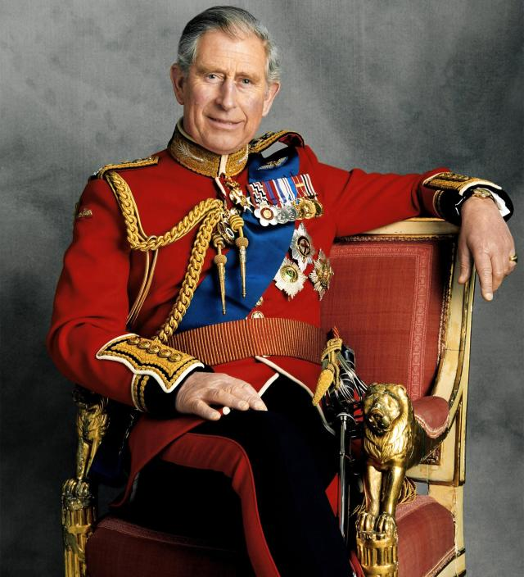
God Save The King

