St Leonards & St Ives Parish Council

The Parish Office
Village Hall, Braeside Road,
St Leonards, Ringwood, Hants, BH24 2PH

Clerk to the Council: Mrs Ann Jacobs
Telephone: 01425 482727 email: office@stleonardspc.org.uk

www.stleonardspc.org.uk

Dear Councillor

PLANNING COMMITTEE MEETING
You are hereby summoned to attend a virtual Planning Committee meeting to be held via Zoom link (separate Zoom invitation provided separately) due to the COVID 19 outbreak and as authorised by the Corona Act 2020 Thursday 2nd July 2020 commencing at 6.45pm, to transact the business listed below:-
Yours sincerely
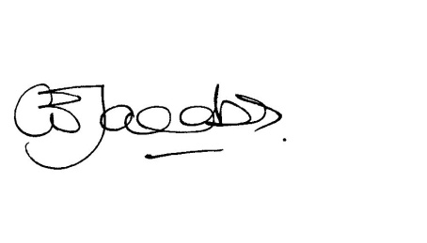
Ann Jacobs
Clerk to Council

Meetings are recorded to facilitate the compilation of the minutes
AGENDA

The Chairman of the Full Council will take the Chair for the Election of the Committee Chairman.

1. Election of Chairman of the Planning Committee for 2020/21

2. Election of Vice Chairman of the Planning Committee for 2020/21

3. Declarations of Pecuniary Interest:

4. Apologies for absence:

5. Public responses/speaking – In these exceptional times the Parish Council is new to virtual meetings, whilst we trust that the link published works, the public may submit and are encouraged to send any comments on the applications below by email to clerk@stleonardspc.org.uk in addition to joining the meeting these will then be circulated to Members. Comments need to be received by 9am on the day prior to the meeting for consideration. You should also ensure that you submit any response direct to Dorset Council electronically or in writing by their deadline.

6. Minutes –To confirm the Minutes of the meeting held on 11th June 2020

7. Matters arising from the Minutes:

8. Correspondence, for information only:
- Name notification new properties rear of 43 Woolsbridge Road, to be known as 43A & 43B

9. Planning Decisions – sent by email

10. Planning Applications:
App | Address | Proposal
20/0098 | 6 Windsor Close, St Leonards And St Ives, , BH24 2LJ | Erect shed to front of the property (Retrospective)
20/0376 | 2 ASHLEY DRIVE NORTH, ASHLEY HEATH, RINGWOOD, BH24 2JL | Minor Material amendment to vary Condition 2 of approved application 3/19/0383/FUL (Sever land and erect 1no 4 bedroom detached chalet bungalow with associated access and parking. Part demolition, alterations and extension to the rear of the existing dwelling.) to vary extent of proposed demolition and erect car port.
20/0501 | 9 Egmont Close, Avon Castle  Ringwood | Replacement dwelling House
20/0556 | UNIT 2A HOLLYGROVE FARM, VERWOOD ROAD, ST LEONARDS AND ST IVES, BH24 2DB | Change of Use from training room to fitness studio
20/0703 | 8 ST LEONARDS WAY, ASHLEY HEATH, BH24 2HS | Side and rear single storey extension

11. Exchange of Information: 1. Next Meeting scheduled for 23rd July 2020 provided sufficient business

