St Leonards & St Ives Parish Council

The Parish Office
Village Hall, Braeside Road,
St Leonards, Ringwood, Hants, BH24 2PH

Clerk to the Council: Mrs Ann Jacobs
Telephone: 01425 482727 email: office@stleonardspc.org.uk

www.stleonardspc.org.uk
4th June 2020

Dear Councillor

PLANNING COMMITTEE MEETING
You are hereby summoned to attend a virtual Planning Committee meeting to be held via Zoom link (separate Zoom invitation provided separately) due to the COVID 19 outbreak and as authorised by the Corona Act 2020 Thursday 11th June 2020 commencing at 6.45pm, to transact the business listed below:-
Yours sincerely
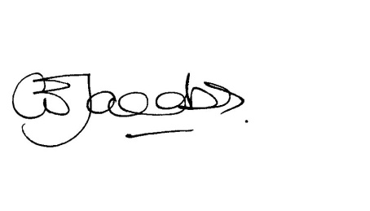
Ann Jacobs, Parish Clerk

Meetings are recorded to facilitate the compilation of the minutes
AGENDA

The Chairman of the Full Council will take the Chair for the Election of the Committee Chairman.

1. Election of Chairman of the Planning Committee for 2020/21

2. Election of Vice Chairman of the Planning Committee for 2020/21

3. Declarations of Pecuniary Interest:

4. Apologies for absence:

5. Public responses/speaking – In these exceptional times the Parish Council is new to virtual meetings, whilst we trust that the link published works, the public may submit and are encouraged to send any comments on the applications below by email to clerk@stleonardspc.org.uk in addition to joining the meeting these will then be circulated to Members. Comments need to be received by 9am on the day prior to the meeting for consideration. You should also ensure that you submit any response direct to Dorset Council electronically or in writing by their deadline.

6. Minutes –To confirm the Minutes of the meeting held on 21st May 2020

7. Matters arising from the Minutes:

8. Correspondence, for information only:
None

9. Planning Decisions – sent by email

10. Planning Applications:
App | Address | Proposal
3/20/0509/FUL | 16 HEATHER CLOSE, ST LEONARDS AND ST IVES, RINGWOOD, BH24 2QJ | Replace existing dwelling and outbuilding with larger two storey dwelling
3/20/0251/FUL | 29 - 31 Woolsbridge Road, St Leonards And St Ives, Ringwood, Dorset, BH24 2LS | Sever land and erect two bungalows (revised scheme)
3/20/0580/HOU | GREENSLEEVES, CHAPEL RISE, ST LEONARDS AND ST IVES, RINGWOOD, BH24 2BL | Single storey rear extension with balcony over and single storey side extension with semi-basement

11. Exchange of Information: 1. Next Meeting scheduled for 2nd July 2020 provided sufficient business

